Design of Linux AtmelDeviceHandler
Date 5/08/11
Author: Aaron Swift

Overview:
The Linux version of the AtmelDeviceHandler class does not correctly handle the firmware upgrade of any ARM based device. This would include the following peripherals: APC, XPEWeigher, XPEPrinter (not released). This is an issue with the Linux versions of the Prepack and Service Scale code only. The Windows versions use a vendor library called SAM-BA to handle the details of upgrading firmware to the devices. Since the vendor (Atmel) does not have a Linux equivalent of this library, bSquare was contracted to duplicate this functionality for the Linux version of our scale code. The code delivered from bSquare did not work. I rewrote only the sections of code that was needed to fix the problem.
System Overview:
When an ARM based peripheral that is in Boot Strapped mode of operation is plugged into the console, the USBManager creates a new instance of an AtmelSambaUpdater. The purpose of the AtmelSambaUpdater is to notify the AtmelDeviceHandler of device arrivals and device removals (see figure 1). Note: both USB Manager and AtmelDeviceHandler are singletons.
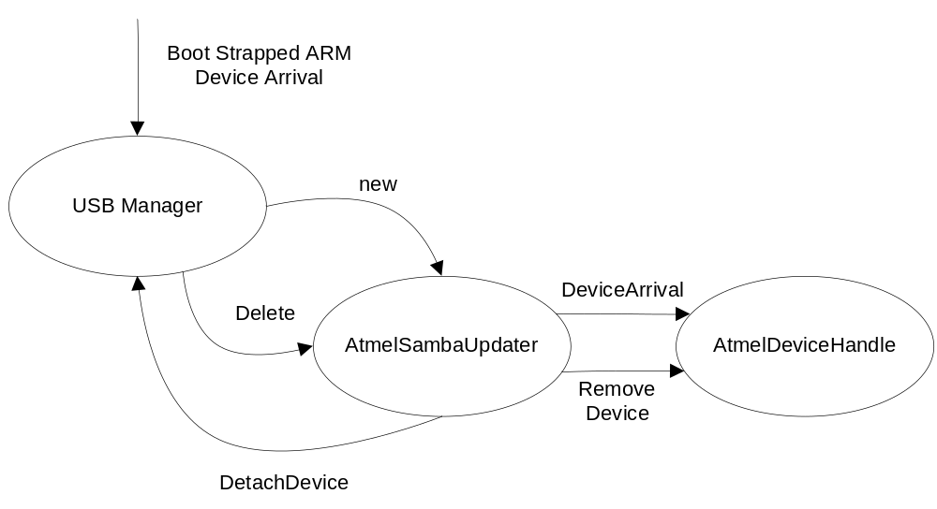
Figure 1.
Upon device arrival, the AtmelDeviceHandler starts the processing of the new device attachment within its state machine (see figure 2).
State Descriptions:
Idle: Waiting for device to be added to the device list.
Scan: finds and verifies the device on the USB bus is an Atmel SAMBA device.
Ident: Opens the device and removes it from list, identifies the device and starts a response timer and requests a code update. The Identification function uses the SAMBA commands to read the following from the device (see figure 3): device silicon revision / vendor id / product id / hardware revision / software revision / device checksum.
WaitVersion: Waits for the Version Manager to send a peripheral code update. If no response, the state will tell the device to launch. The code update is verified and transitions to the Update state.
Update: Downloads and launches the new version of firmware and closes the device. If the download or launch fails, the state transitions back to the Ident state. If successful with the download and launch, the state transitions to the Detach state (see figure 4).
Detach: Waits for a device removal then transitions to the idle state.

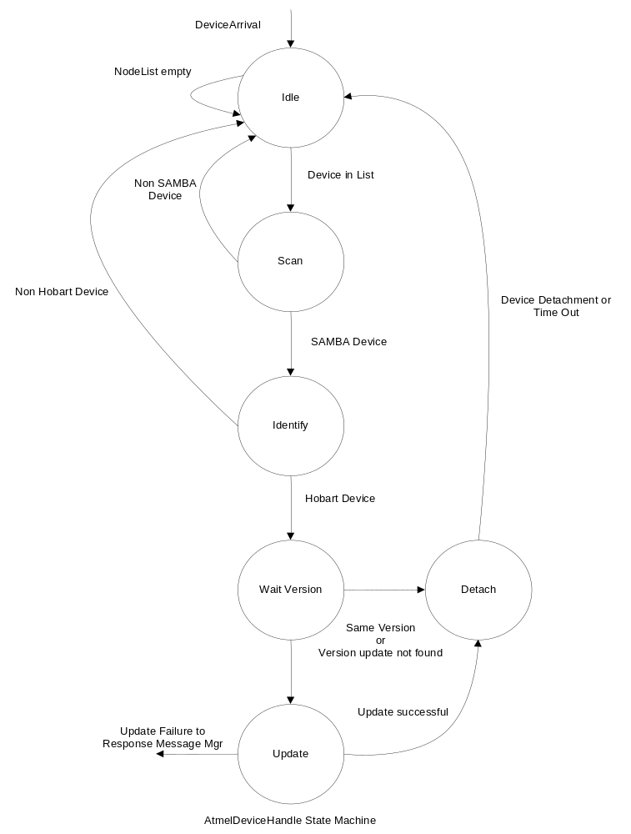
Figure 2.
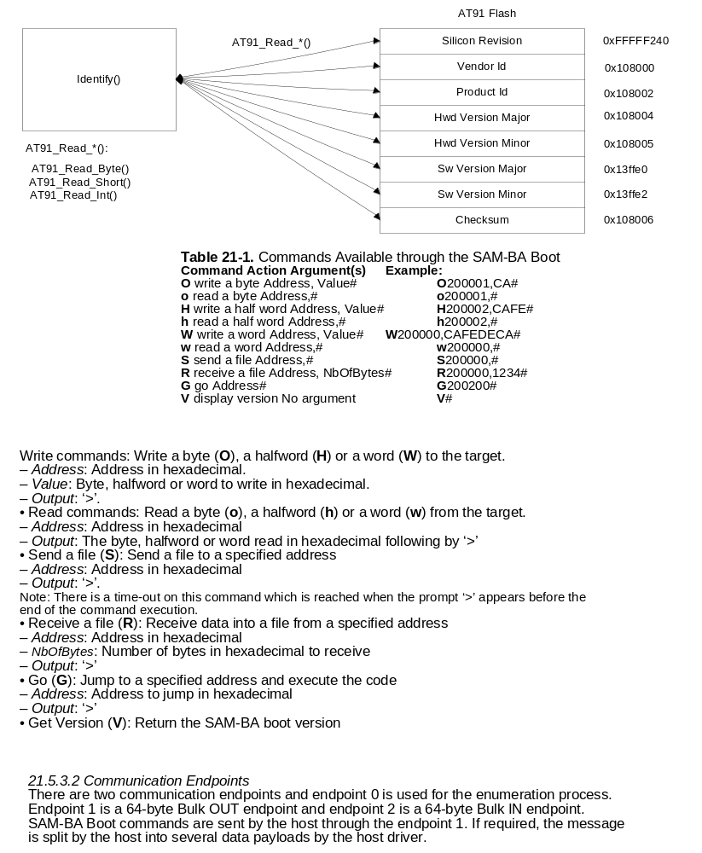
Figure 3.

Device Communication:
Communication with the SAM-BA device is achieved using the libusb library and using the communication endpoints detailed in section 21.5.3.2 of figure 3.
Update process:
The code update process is accomplished with a set of sequenced steps.
Step 1: configure the AT91 flash controller.
Step 2: Load the AT91 loader image into a specified RAM location.
Step 3: verify the AT91 flash controller is ready for operations (Erase / Write).
Step4: Write the initial page counter value to a specified RAM location. This initial page counter value is the starting location of the device application (Weigher / Printer code).
Step5: Send a file command with the file size set to 266 bytes. 256 bytes is for the page image which is referenced by our page counter value and an additional 10 byte GO command with the address set to the start of the loader image. After the loader has finished writing the page, the Go command will cause the loader function to jump back to itself and start execution.
Step 6: Send the page image + Go command to the AT91.
Step 7: Increment or page count and repeat steps 5 and 6 until all device pages are written.
Step 8: Launch device application with a GO command.

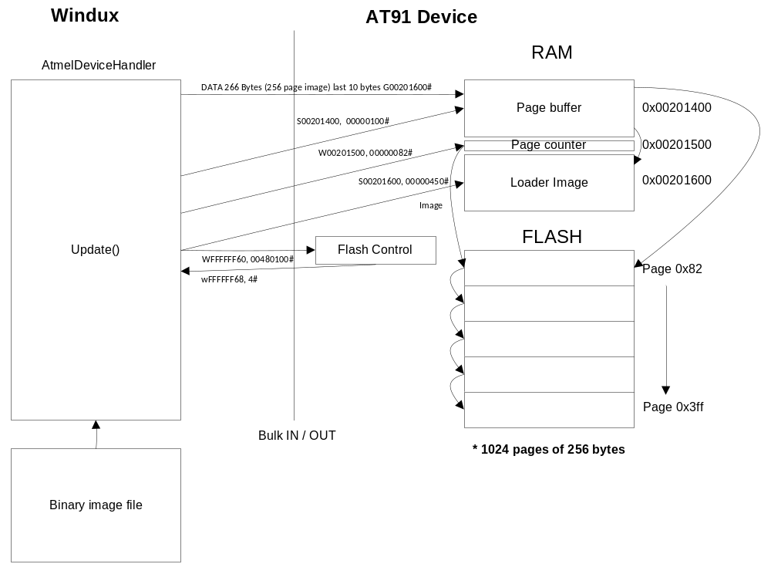
Figure 4.

